**KUBERNETIES**

**CONNECY**

* **Sudo su –**
* **Apt update –y**
* sudo curl -fsSL https://get.docker.com -o get-docker.sh(install docker)
* ll
* 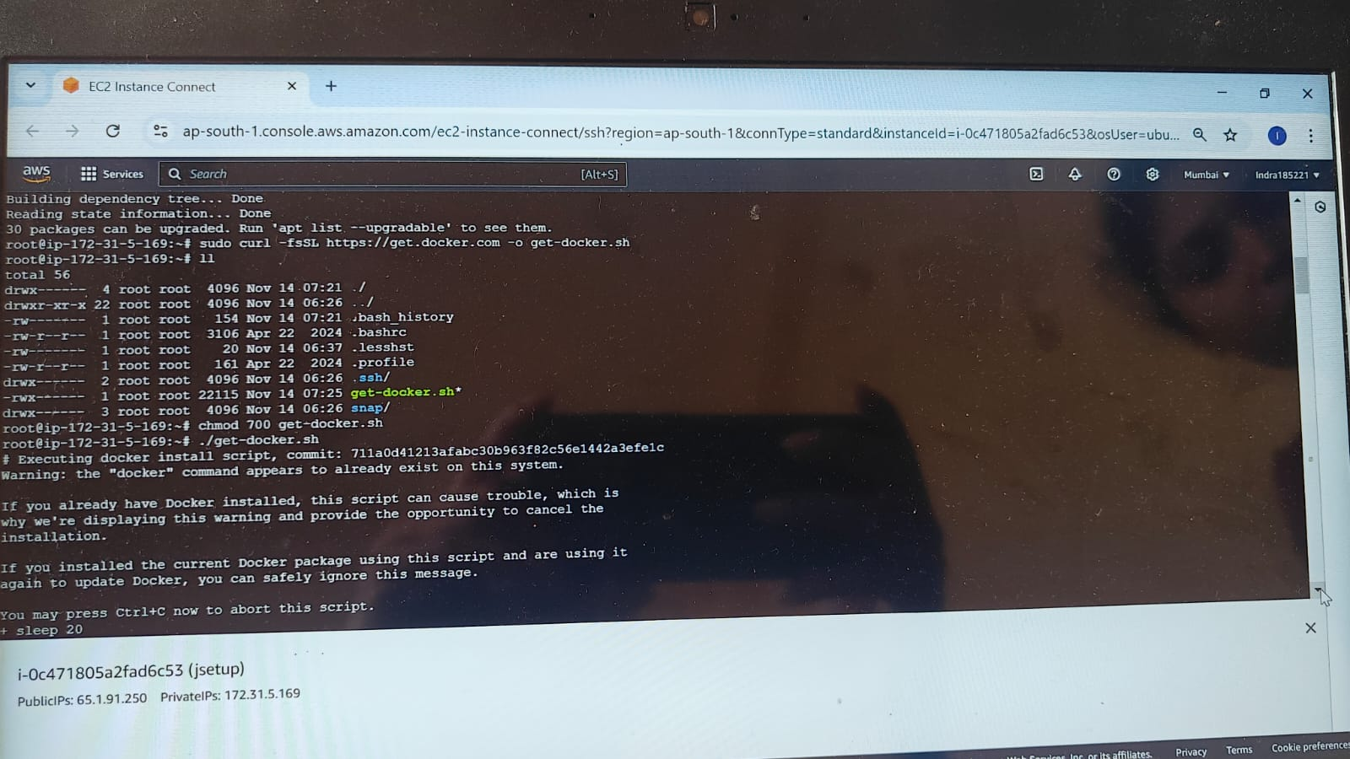
* chmod 700 get-docker.sh(provide permissions)
* ./get-docker.sh
* Docker –version
* 
* Systemctl status docker
* Apt update –y
* sudo mv minikube-linux-amd64 /usr/local/bin/minikube
* ll
* sudo chmod +x /usr/local/bin/minikube
* ll
* sudo minikube version
* 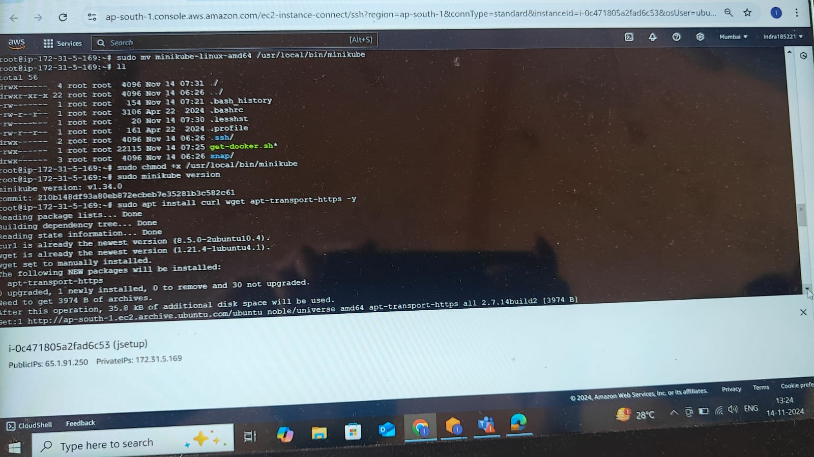
* sudo curl -LO "https://dl.k8s.io/release/$(curl -L -s https://dl.k8s.io/release/stable.txt)/bin/linux/amd64/kubectl"
* sudo curl -LO [https://dl.k8s.io/$(curl -L -s https://dl.k8s.io/release/stable.txt)/bin/linux/amd64/kubectl.sha256](https://dl.k8s.io/$(curl%20-L%20-s%20https://dl.k8s.io/release/stable.txt)/bin/linux/amd64/kubectl.sha256)
* sudo kubectl version --client
* sudo echo "$(cat kubectl.sha256) kubectl" | sha256sum --check
* sudo install -o root -g root -m 0755 kubectl /usr/local/bin/kubectl
* sudo install -o root -g root -m 0755 kubectl /usr/local/bin/kubectl
* sudo kubectl version --client --output=yaml
* 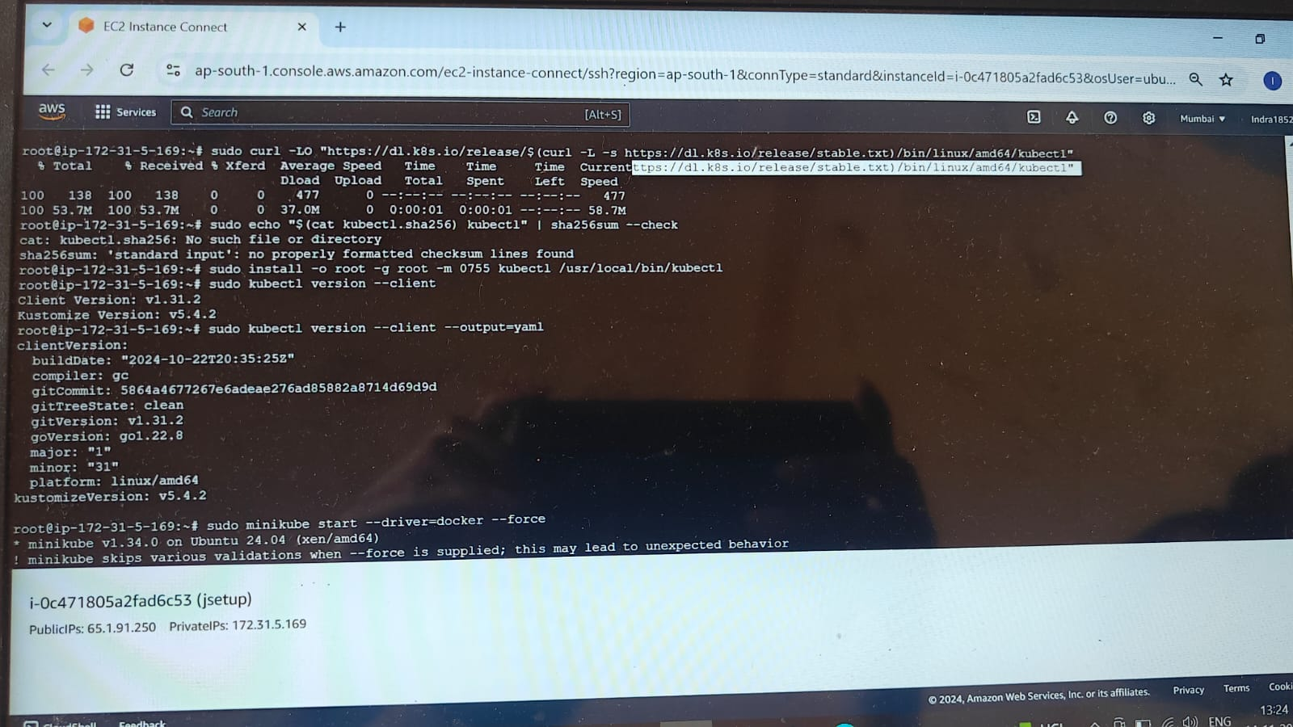
* sudo minikube start --driver=docker --force
* **kubectl run pod1 –image=nginx**
* **kubectl get pods**
* 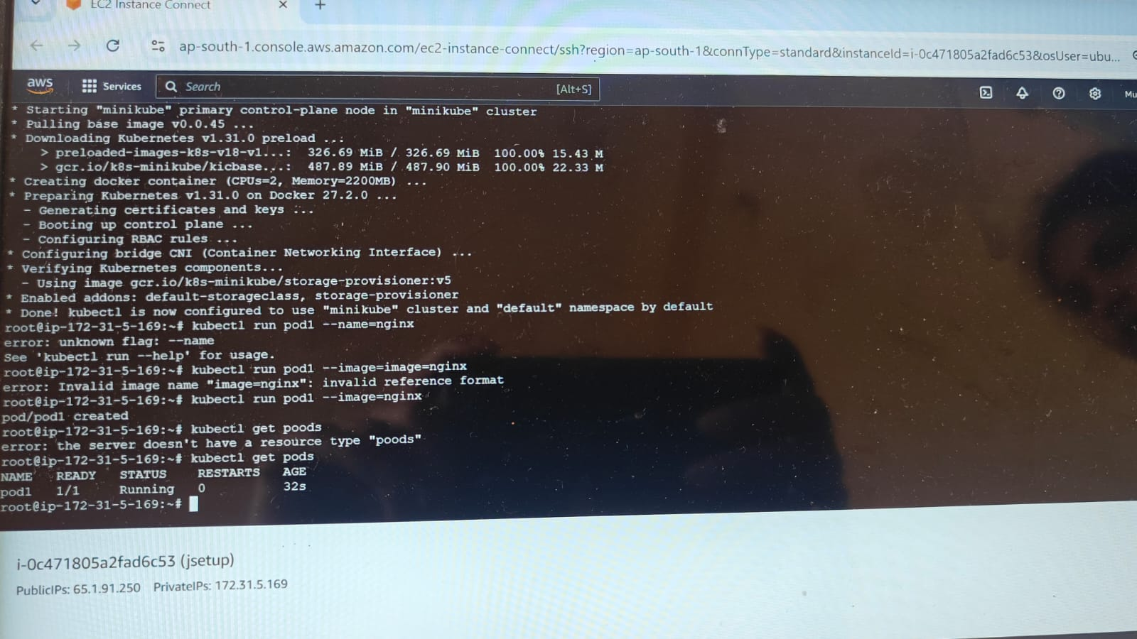
* **vi indra.yml**
* **give instructions like bellow**
* 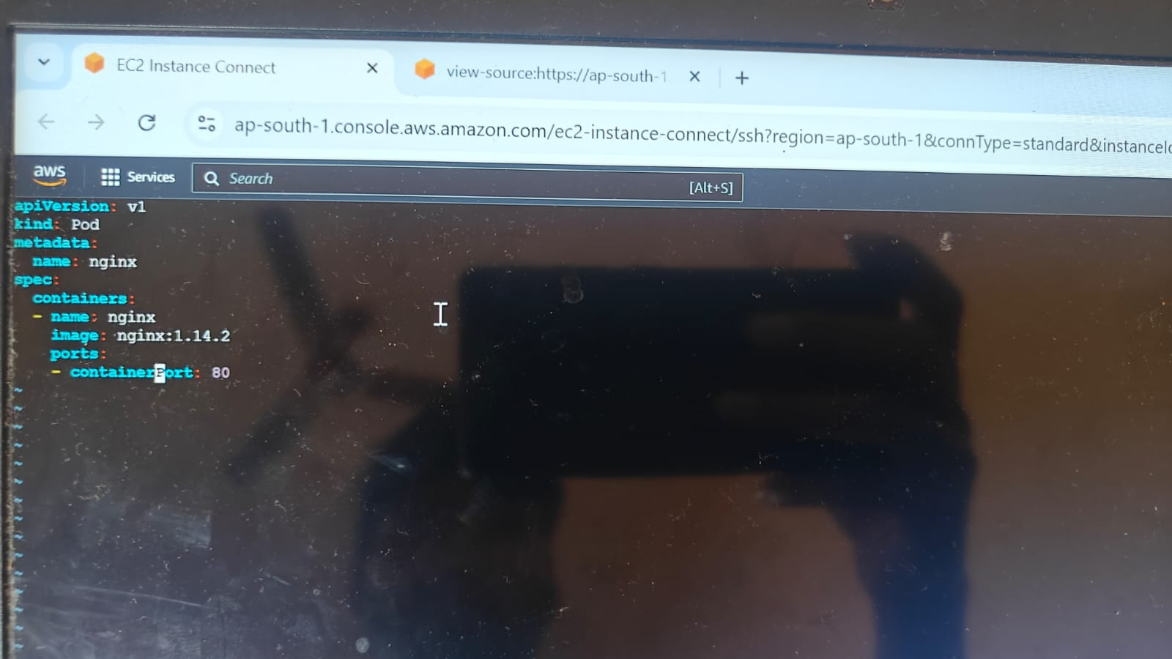
* **kubectl create –f indra.yml**
* **kubectl get pods**
* 